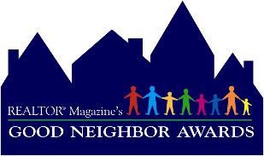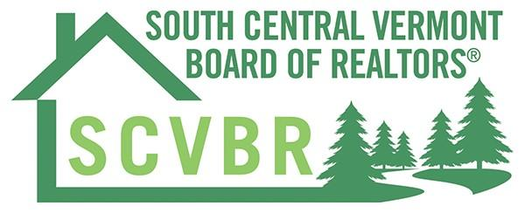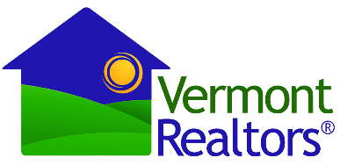

2026 SCVBR Good Neighbor Awards

Official Entry Form
Deadline: May 6, 2026

Send completed nomination forms to Christina Dryden at Christina@strattonhome.com
(Please note that not every category needs to be completed for a valid nomination.)

Nominee Name:

Real Estate Designations (abr, crs, etc.) ____________________________________________________

Brokerage Firm:

Firm’s Mailing Address: ________________________________________________________________

Cell Phone: Email: _________________________________________

Website: ____________________________________________________________________________

Designated Broker: Direct Phone: ____________________________

M1 (formerly NRDS) ID#: ____________________________
(Obtain your ID# at www.realtor.org. Log in or register there, and click on “NRDS” to search for your number.
You can also find the number printed above your name on the address label on REALTOR Magazine.)

NOMINATED BY:
Name:

Company/charity:

Address:

Cell Phone: E-mail:_________________________________________

How do you know the Nominee?

____________________________________________________________________________________
____________________________________________________________________________________

ESSAY Explanation of Contribution (Required)
In no more than 500 words, describe how the nominee’s individual efforts have made the community a better place to live. (Use a separate page if needed.)
___________________________________________________________________________________________________________________________________________________________________________________________________________________________________________________________________________________________________________________________________________________________________________________________________________________________________________________________________________________________________________________________________________________________________________________________________________________________________________________________________________________________________________________________________________________________________________________________________________________________________________________________________________________________________________________________________________________________
____________________________________________________________________________________________________________________________________________________________________________________________________________________________________________________________________________________________________________________________________________________________________________________________________________________________________________________________________________________________________________________________________________________________________________________________________________________________________________________________________________________________________________________________________________________________________________________________________________________________________________________________________________________________________________________________________________________________
____________________________________________________________________________________

Feel free to use additional paper if necessary.

ELIGIBILITY CRITERIA:
1. Nominees must be members of VAR in good standing.
2. Nominees should have contributed to a program that improves the livability of a local community. Those activities are not limited to real estate or housing issues, and may include such things as crime prevention, youth mentoring, and homelessness prevention.
3. Nominees should have made a significant contribution of personal time, but contributions of money, materials, or other resources will be considered by the judges as well.
4. Nominees will be judged on level of personal contribution, impact of personal contribution, broadness of impact, and the project’s suitability as a role model for other REALTORS®
5. The award is intended to recognize individual contributions, not association- or company-wide efforts. However, if an individual within your company can be singled out as instrumental to the success of a group effort, he or she is eligible. If the achievements of two people (such as a married couple or co-founders of an organization) absolutely cannot be separated, they can enter as a pair and their entry will be considered as one.
6. Some portion of the nominee’s community work must have taken place between January 2024 and December 2024, but judges will also consider ongoing efforts outside that time frame that demonstrate a depth of commitment.
7. Nominees should be able to document the results of their individual involvement though published reports and/or testimonials from the organization they served or the people they helped.
8. Nominations must be accompanied by a completed entry form to be considered (REALTORS® may nominate themselves or may be nominated by another SCVBR member, a state or local association, or the community organization they served).

